ASSignMENT 2: Data pipeline
Subject: Data Engineering and Python (BUS2003)
Name: Ngoc Anh Hoang.
Student ID: 21975674.
Submission date: 16/05/2026.

Table of Contents
Introduction 1
PART 1: ETL Pipeline 1
I. Extract 1
1. Data Orientation and Data Types 1
2. Data Assessment Categories 3
3. Data Assessment overview 4
II. Transform 4
1. Converting Data Types 6
2. Removing Duplicate 6
3. Fixing Categorical Inconsistency and Format Text 6
4. Handling Missing Values 7
5. Treating Outliers 7
6. Creating Derived Variables 8
III. Load 9
PART 2: Exploration 10
I. Visualisations clarification 10
II. Question 1: Property Subtype and Sale Amount 11
III. Question 2: Area and Sale Price Variation 12
Reference

List of Tables
Table 1. Variable names, Data types and expected format………….………………………………………………1
Table 2. Missingness Assessment……………………………………………………………………………………………….4
Table 3. Problems vs Actions matching………………………………………………………………….…………………..5
Table 4. Final Dataset Summary…………………………………………………………………………..…………………..10
Table 5. Summary Table of transaction values of each property subtype………..…….………….……..12
Table 6. Summary Table of price per sqm values of each area………………………...……………………….13

List of Figures
Figure 1. Data Assessment Dashboard……………………………………………………………………………………….3
Figure 2. Before vs After Cleaning Dashboard……………………………………………………………..……………..9
Figure 3. Analysis of Property Subtype and Sale Amount Dashboard………………………………….……11
Figure 4. Analysis of Area and Sale Price Variation……………………………………………………………….….14

Introduction
This report documents the development of an end-to-end ETL pipeline for the Dubai property sales dataset. The dataset contains 81,601 property transaction records and 22 variables covering transaction details, property characteristics, location information, sale amount, and project-related fields. The purpose of the pipeline is to convert the raw CSV file into a cleaner and more reliable dataset suitable for descriptive analysis. The report first assesses the raw data to identify quality risks, then explains the transformation steps used to resolve these issues. The cleaned dataset is then used to explore price variation by property subtype and area.

PART 1: ETL Pipeline

Extract

Data Orientation and Data Types
The dataset was extracted from a CSV file and imported into Python using pandas. The raw dataset contains 81,601 rows and 22 columns with each row representing one property sale transaction of the first six months in 2023, where each row represents one Dubai property sales transaction. Overall, these variables can provide useful information for analysis. However, derived variables such as price per sqm can be added. The dataset includes:

Column | Current Type | Expected values/format
transaction_number | Object | Text ID, since there are hyphens in the IDs, should ideally be unique and non-missing
transaction_date | Object | Valid date format, should be datetime
transaction_type | Object | Categorical text such as sales-related transaction type
transaction_sub_type | Object | Clean categorical text with no extra whitespace
registration_type | Object | Categorical text
is_free_hold | Object | Categorical text or Boolean-style value
usage | Object | Residential, commercial, or similar category
area | Object | Clean text, no leading/trailing whitespace
property_type | Object | Clean categorical text
property_sub_type | Object | Clean categorical text such as Flat, Villa, Residential, Commercial
amount | Float64 | Numeric, non-negative, realistic property sale amount
transaction_size_sqm | Float64 | Numeric, non-negative square metres
property_size_sqm | Float64 | Numeric, non-negative square metres
room | Object | Consistent text such as “1 Bedroom”, “2 Bedroom”, or NA for blank values
parking | Object | Clean text/category; missing values should be clearly coded
nearest_metro | Object | Clean text or NA for blank values
nearest_mall | Object | Clean text or NA for blank values
nearest_landmark | Object | Clean text or NA for blank values
no_of_buyer | Int64 | Integer, normally positive, no negative values
no_of_seller | Int64 | Integer, normally positive, no negative values
master_project | Object | Clean text or NA for blank values
project | Object | Clean text or NA for blank values
Table 1. Variable names, Data types and expected format

Data Assessment Categories
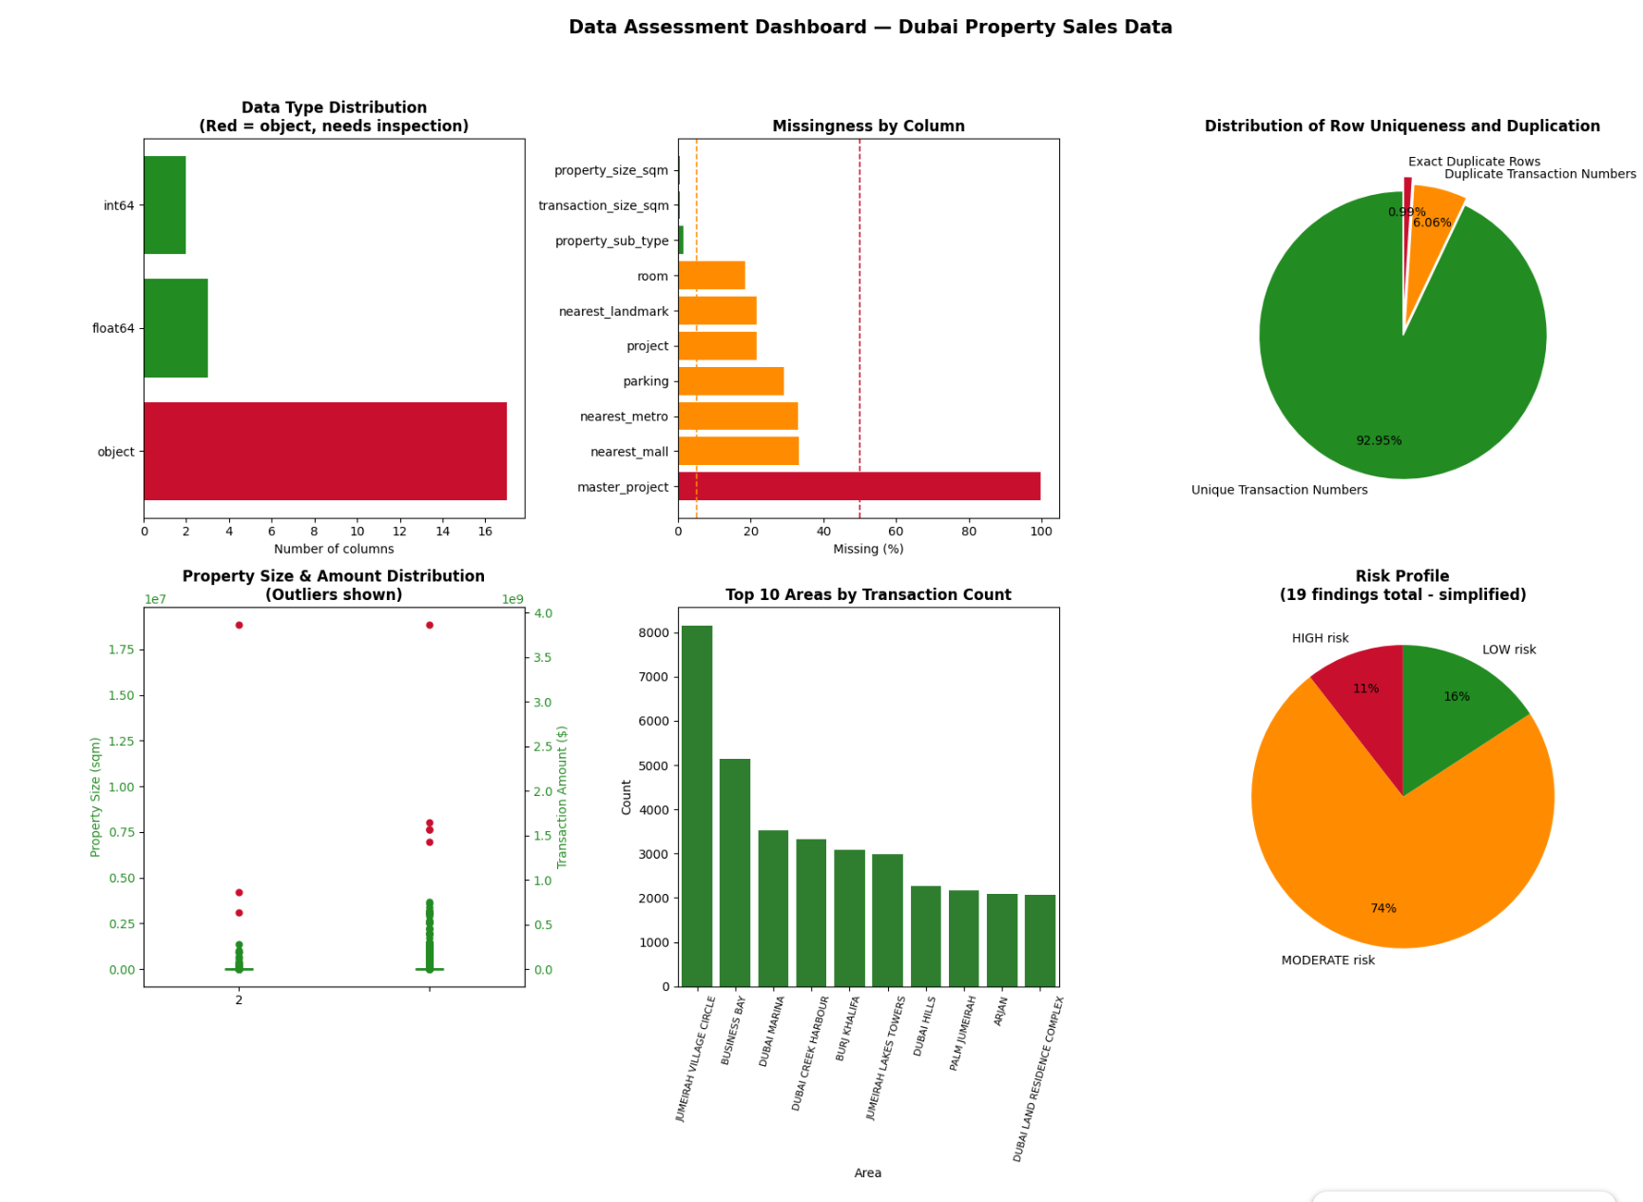
Figure 1. Data Assessment Dashboard
Regarding Data Types, object columns dominate the raw dataset, which is expected because real estate data contains many categorical fields. A positive sign is that key numeric columns, including amount, property_size_sqm, no_of_buyer, and no_of_seller, were already recognised correctly. However, transaction_date was stored as an object, limiting time-based analysis. This limits time-series operations, such as sorting by transaction date, filtering by month, or analysing price changes over time. Moreover, is_free_hold and parking could be a boolean data type since they are 2-value (yes/no) columns. However, for a more meaningful data value, they should stay as an object (string).
Turning to Missingness, the dataset contained 211,902 missing cells, equal to 11.8% of all values. Core variables such as amount were complete, which supports price analysis. However, master_project had 99.9% missingness, making it unsuitable for analysis. Moderate missingness in location and feature variables may reduce analytical depth and requires careful treatment. Checking the encoded missingness check, there was no column with an encoded missing value. However, there could be values such as ‘NA’, ‘None’ that are detected as strings and are ignored. Therefore, this should be treated carefully in the Transform stage.
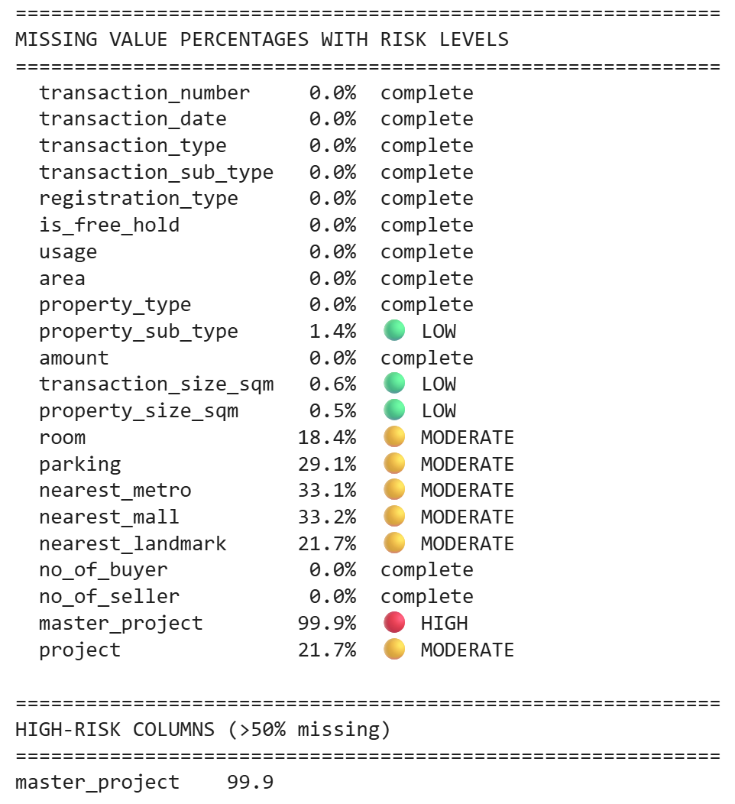
Table 2. Missingness Assessment
As regards Uniqueness, most records were unique, with around 92.95% of transaction numbers appearing only once. This suggests duplication does not dominate the dataset. However, 808 exact duplicate rows and 5,753 duplicate transaction numbers were identified. Exact duplicates should be removed, while duplicate transaction numbers should be reviewed carefully because some may represent valid related records.
The assessment found that many categorical variables were generally usable, but some required formatting. Most categorical variables, such as transaction_type, registration_type, is_free_hold, usage, and property_type, were logically structured. However, some columns required cleaning. The room column contained inconsistent labels such as “1 B/R” and “1 bedroom”, while parking contained codes rather than indicating whether there was parking or not. These inconsistencies could distort grouping and visualisation. Moreover, some columns have whitespace contamination and many major categorical variables were already logically structured and could be used after basic formatting.
The numerical assessment found no impossible values, such as negative prices or negative property sizes, suggesting the data is broadly valid. However, 6,358 outliers were detected in amount and 11,015 in property_size_sqm. These extreme values may be legitimate real estate transactions, so they should be assessed carefully rather than deleted automatically. However, there are extreme property values, which can heavily distort averages and make visualisations unreadable. For example, 3 values of extremely large property sizes or 5 of sale amounts may cause normal transactions to appear compressed in charts.

Data Assessment overview
Figure 1 shows that transaction activity is not evenly distributed across areas. This means some areas have enough records for stable analysis, while many smaller areas may have limited transaction counts. However, after data cleaning, data distribution might alter across the areas.
The risk profile shows that most identified issues are moderate risk, with fewer high-risk issues. The dataset is therefore usable, but not immediately analysis-ready. Overall, the dataset has a strong foundation because the key price, property, and transaction variables are mostly present, and no impossible numeric values were found. However, without transformation, the dataset could produce misleading grouped results, inflated counts, distorted averages, and unclear visualisations.

Transform
The Transform stage addressed the quality issues identified during the Extract stage and prepared the dataset for reliable analysis. The cleaning process was applied systematically so that the dataset could be improved without removing valid transaction information unnecessarily.
Problem identified in the Extract stage | Actions
The date column was not stored in a proper datetime format, which could limit chronological sorting, filtering, and future time-based analysis. | Convert transaction_date from object/string to datetime format
The dataset contained 808 exact duplicate records, which could inflate transaction counts and distort summary statistics. | Remove exact duplicate rows
Several categorical columns, contained whitespace contamination that could split the same category into multiple inconsistent labels. And inconsistent capitalisation and formatting could reduce the accuracy of grouping, filtering, and visualisation | Strip whitespace, standardise text formatting from text columns
The room column used inconsistent labels such as 1 B/R and 1 bedroom. The parking column contained slot codes and symbols. These make it unsuitable for direct categorical analysis. | Clean the room columns as well as other categorical variables, replace values in the parking column
master_project had 99.9% missing values, and several columns had moderate missingness. | Treat missing values with suitable strategies
The amount and property_size_sqm column had extreme outliers that could distort averages, summary statistics, and visualisations. | Cap unrealistic extreme values in amount and property_size_sqm
no_of_buyer and no_of_seller had outliers, but no impossible negative values were found. Multiple buyers or sellers may be valid in property transactions. | Cap amount and property_size_sqm extreme values. Inspect buyer and seller count outliers without aggressive removal
Some other variables can be created for future analysis | Create derived variables
The raw file was not analysis-ready, so the transformed output needed to be saved as a structured, cleaned dataset for the Load and Exploration stages. | Export the cleaned dataset as a new CSV file
Table 2. Problems and Actions matching

Converting Data Types
The transformation process began by correcting the data type of transaction_date. In the raw dataset, this column was stored as an object, even though it represents a date variable. It was converted using pd.to_datetime, which changed the column into datetime64[ns] format. This made the dataset structurally more suitable for chronological sorting, filtering, and future time-based analysis. Although the final exploration focuses on property subtype and area, correcting the date format improves the overall reliability of the dataset.

Removing Duplicate
Duplicate handling was then applied. The raw dataset contained 808 exact duplicate rows, which were removed because they repeated the same information and could overstate transaction activity. Removing these records improved the reliability of transaction counts and summary statistics. However, duplicate transaction_number values were not automatically removed. Further investigation showed that some rows with the same transaction number had different details, such as different nearest_metro values. This suggests that repeated transaction numbers may be caused by multi-valued attributes or related transaction records rather than true duplicates. Therefore, these records were retained to avoid deleting potentially valid transaction information, although this remains a key integrity limitation.

Fixing Categorical Inconsistency and Format Text
Categorical cleaning was important because the analysis depends heavily on grouping variables such as area and property_sub_type. The room column was standardised by replacing abbreviated labels such as B/R with Bedroom and applying consistent title-case formatting. This prevented equivalent values, such as 1 B/R and 1 bedroom, from being counted as separate categories. Values such as Studio, Shop, Office, Penthouse, and Hotel were retained because room functions as a categorical feature rather than a purely numeric bedroom count.
The parking column was also cleaned before changing into a 2-value column. This was appropriate because the column contained parking codes, symbols, and missing-value strings, which cannot contribute to the analysis. The cleaning process ensured texts of ‘NA’, ‘N/A’ or values starting with ‘–‘ (negative values) were detected as blank. Then the blank values or 0 were filled with ‘No Parking’, and the rest should be filled with ‘Has Parking. This improved the usability of the column instead of random codes.
Other text columns, including area, project, transaction_sub_type, and nearest_metro, were standardised by removing leading and trailing whitespace and formatting text consistently. This was especially important for the area, because inconsistent spelling or spacing could split the same location into multiple artificial categories. Numeric fields such as amount, transaction_size_sqm, and property_size_sqm were also rounded to two decimal places to improve readability and reporting consistency.

Handling Missing Values
Missing values were treated based on their severity and the role of each column. The master_project column was removed because it had 99.9% missing values. At this level, the column provides almost no useful information and would mostly function as an empty field. Removing it reduced noise and simplified the dataset. The parking column was detected with missing values at first, but it has been filled with ‘No Parking’ in the earlier stage.
Before filling missing values, text-based missing labels such as nan, NaN, and None were converted into actual missing values. This ensured that missingness was handled consistently rather than stored as misleading text categories. Missing values in categorical columns, including nearest_metro, nearest_mall, nearest_landmark, project, and room were filled with NA. This preserved transaction records and made “not recorded” visible as a valid category. This approach was more suitable than deleting rows because several of these columns had moderate missingness.
For property_sub_type, missing values were filled using a logical rule. Most missing subtype records were linked to ‘Land’ in the broader property_type column. Since land transactions may not require a more detailed subtype, these missing values were filled as ‘Land’. This improved completeness for the exploration question on property subtype.
The two size variables were also reviewed. Since transaction_size_sqm and property_size_sqm were 96.18% identical, they were highly redundant. Missing values in property_size_sqm were filled from transaction_size_sqm where possible, then transaction_size_sqm was dropped to simplify the dataset. Any remaining missing value in property_size_sqm was left blank because it is a numeric column, and filling it with text, such as NA, would damage its data type.

Treating Outliers
Outliers were investigated carefully rather than removed automatically. This was important because real estate data naturally includes large variation, especially for land, commercial properties, and luxury assets. After the above cleaning steps, the number of outliers and extreme values in amount, property_size_sqm, no_of_buyer, and no_of_seller have changed.
For no_of_buyer and no_of_seller, the IQR method was not fully appropriate because most values were concentrated around one, making values above one appear as outliers. However, multiple buyers or sellers can be realistic in property transactions, and there were no unrealistically high or low values, so these values were retained.
For amount and property_size_sqm, extreme rows were investigated further. Many high values were associated with land transactions, which can reasonably have larger sizes and higher prices than apartments or units. Therefore, these values were not all deleted. Instead, only unrealistic extreme values were capped. Extreme land-related values were capped to the highest acceptable fence, reducing distortion. And one unusually high hotel transaction amount was capped at the upper fence because it appeared inconsistent with other hotel records. Capping was preferred over deletion because it preserved transaction records while reducing the impact of extreme values on summary statistics and visualisations.

Creating Derived Variables
Finally, an important derived variable was created. price_per_sqm was calculated by dividing the amount by property_size_sqm. This supports fairer comparison across properties and areas because the total sale price is strongly affected by property size. Overall, the Transform stage improved consistency, completeness, and analytical usefulness, making the dataset suitable for the Load and Exploration stages.

Load
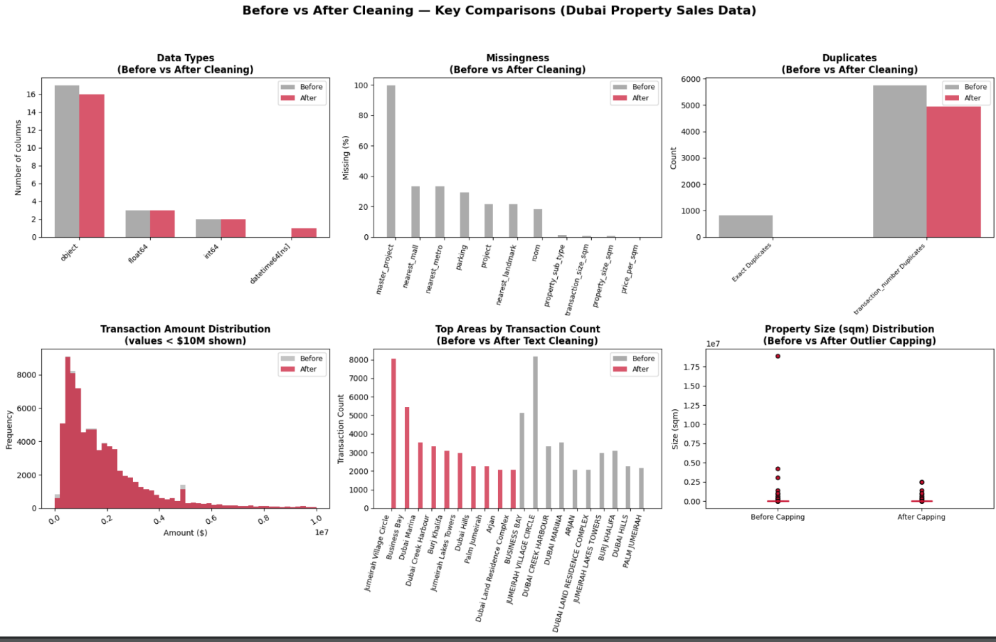
Figure 2. Before vs After Cleaning Dashboard.
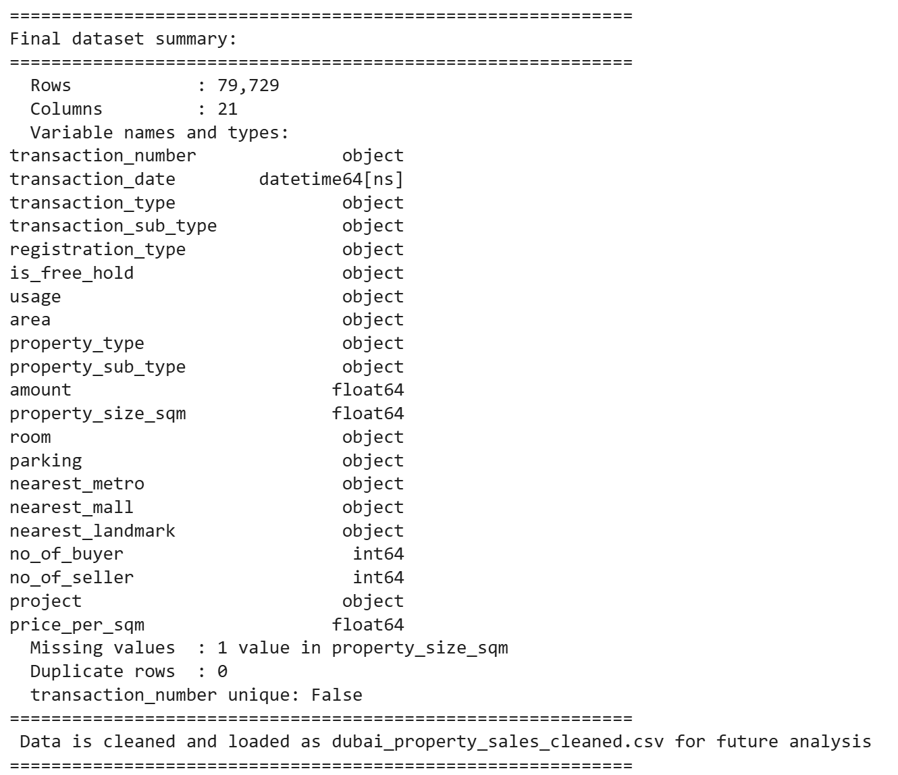
Table 3. Final dataset summary.
The cleaned dataset was loaded and saved as a structured CSV file named dubai_property_sales_cleaned.csv, making it available for the final exploration stage and future analysis. After transformation, new duplicated rows have been deleted; the dataset contained 79,729 rows compared with the original 81,601 rows, mainly reflecting the removal of exact duplicate records. Although 2 columns were dropped (master_project and transaction_size_sqm), 1 derived variable was added to support more meaningful comparison across properties, making the number of columns 21.
According to the Data Types chart, the data types of variables mostly remained the same. Only the transaction_date column was successfully converted from object format to datetime64[ns], for more suitable filtering, sorting, and future time-based analysis.
Looking at the Missingness chart, the missing-value profile improved substantially after transformation. The original dataset contained severe missingness in master_project and moderate missingness in several location and property-feature columns. After cleaning, master_project was removed, categorical missing values were filled, and only one missing value remained in property_size_sqm. This indicates that the final dataset is largely complete for the intended analysis.
The Duplicates chart confirmed zero exact duplicate rows, although transaction_number remained non-unique. This means the dataset is suitable for descriptive analysis, but the transaction number should not be treated as a fully reliable primary key without further business validation.
Based on the next two charts, the distribution of transaction amount and the count among the areas after cleaning have not changed significantly. Moreover, the outlier treatment also improved the usability of the data since extreme values in amount and property_size_sqm were capped rather than deleted. This indicates that the cleaning process improved data quality while preserving the underlying market structure, as the major transaction areas remained consistent before and after transformation rather than being reshaped by the cleaning steps. Overall, the cleaned dataset is ready for exploration because its structure is more consistent, missingness is minimal, exact duplicates have been removed, and key analytical variables are available in usable formats.

PART 2: Exploration

Visualisations clarification
For exploration, the analysis uses unique transaction_number instead of row counts because some transaction_number values are duplicated due to multi-valued attributes, giving a more accurate view of actual market activity by property subtype. For question 1, the cleaned dataset contains 36 property subtypes, but many have very small transaction counts: 20 subtypes have fewer than 50 transactions out of 80,000. Therefore, the analysis focuses only on the top 10 subtypes by unique transaction count. For question 2, the cleaned dataset contains 252 areas, but only the areas with more than 100 transactions were chosen for analysis. For both questions, boxplots were selected because it compares the full sale amount distribution across subtypes, including the median, spread, and outliers. A log scale was used because sale prices are highly skewed, and large transactions would otherwise make lower-value transactions difficult to read.

Question 1: Property Subtype and Sale Amount
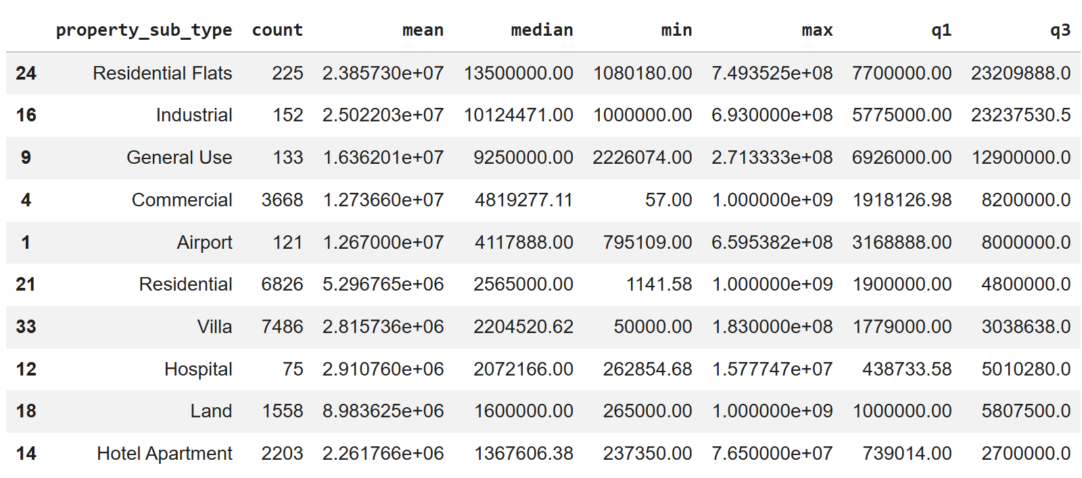
Table 4. Summary Table of transaction values of each property subtype

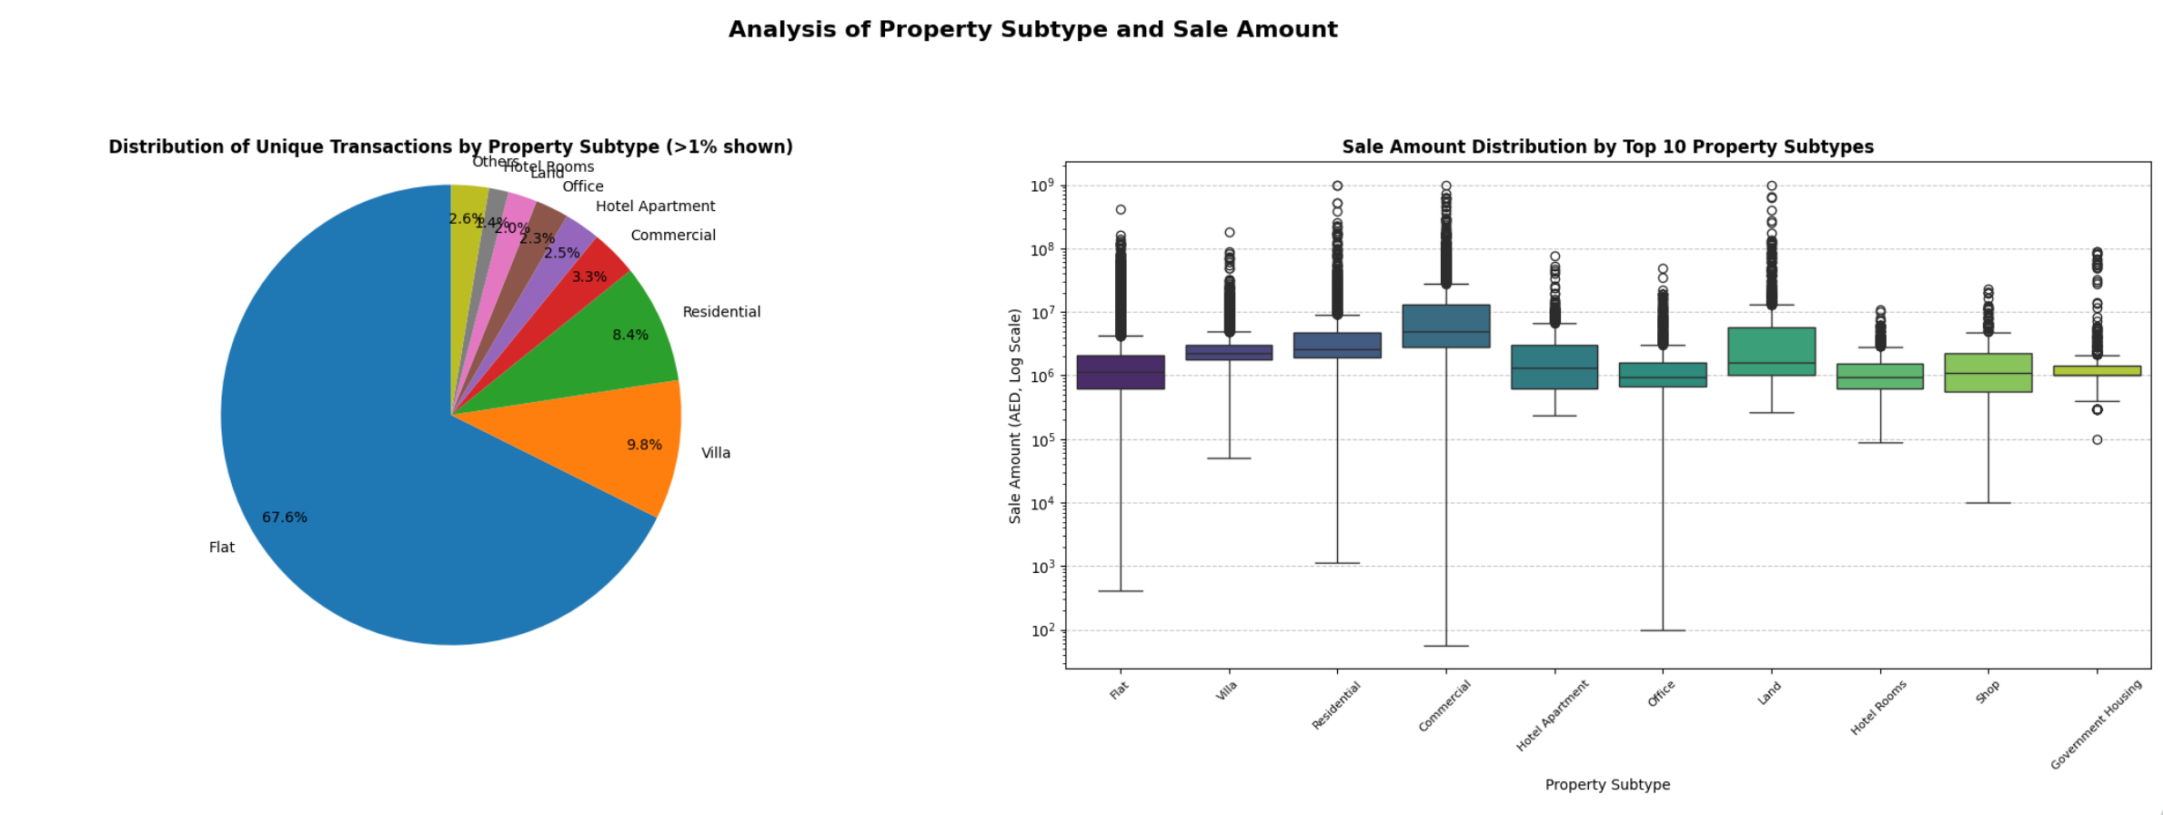
Figure 3. Analysis of Property Subtype and Sale Amount Dashboard
The summary table, pie chart, and boxplot show that property subtype has a strong relationship with sale amount, but the relationship is different between transaction volume and transaction value. The pie chart shows that market activity is highly concentrated in Flats, which account for 67.6% of unique transactions, followed by Villas and Residential properties (Figure 3). This means Flats are the dominant subtype in the dataset and represent the main transaction segment of the Dubai property market. This dominance can be explained by the structure of Dubai’s residential market, where apartment sales are strongly supported by off-plan developments, broader affordability, and investor demand (Engel & Völkers, 2023). However, the summary table shows that Flats are not among the highest-value subtypes by median sale amount. Instead, higher median prices are found in more specialised subtypes, such as Residential Flats with a median of AED 13.5 million, Industrial at about AED 10.1 million and General Use at AED 9.25 million.
The boxplot shows that the sale amount differs clearly across the top property subtypes. Commercial properties appear to have the highest median and widest price range, followed by Residential, Villa, and Land. This suggests that larger or business-use assets tend to sell at higher and more varied prices than standard apartment units. Flats dominate transaction volume, but their median sale amount is lower, indicating that they represent the mass-market segment rather than the highest-value segment. This pattern is consistent with Dubai market reports showing that apartments were the most transacted property type in 2023, while villas and premium residential assets recorded stronger price levels in many locations (Savills, 2023). The many upper outliers also reflect Dubai’s active luxury segment, where high-value transactions can strongly exceed typical market prices.

Question 2: Area and Sale Price Variation
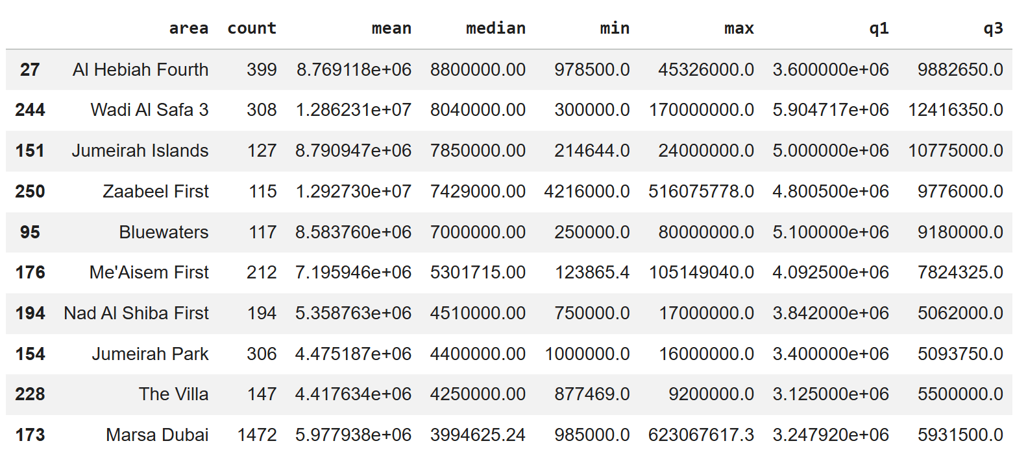
Table 5. Summary Table of price per sqm values of each area.
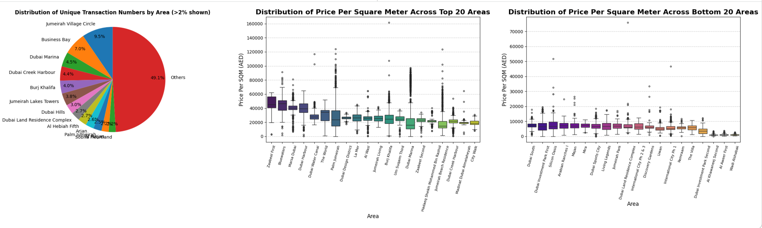
Figure 4. Analysis of Area and Sale Price Variation.
The area-level analysis shows that Dubai property transactions are widely distributed across 245 areas, but activity is concentrated in a small number of major locations. The pie chart shows that Jumeirah Village Circle has the highest share of unique transactions at 9.5%, followed by Business Bay at 7.0%, Dubai Marina at 4.5%, and Dubai Creek Harbour at 4.4%. However, the “Others” group (the group of areas constitute lower than 2%), represents 49.1%, showing that the Dubai property market is geographically broad, with many smaller areas contributing lower transaction volumes.
The summary table shows that areas with the highest median sale amounts are not always the areas with the highest transaction counts. Al Hebiah Fourth recorded the highest median sale amount at AED 8.8 million, followed by Wadi Al Safa 3 at AED 8.04 million and Jumeirah Islands at AED 7.85 million. These areas appear to represent higher-value property markets, likely because they contain larger homes, premium developments, land transactions, or luxury residential assets (Bandyopadhyay, 2025). In contrast, high-volume areas such as Jumeirah Village Circle and Business Bay dominate transaction activity but do not necessarily appear at the top of the median sale amount ranking. This is likely because these areas contain large apartment markets with high liquidity and broader buyer accessibility (Metropolitan Premium Properties, 2026).
The price-per-sqm boxplots provide a fairer comparison because the total sale price can be affected by property size. The top-area boxplot shows that premium areas such as Al Ras, Marsa Al Arab, Al Dhagaya, Island 2 and Jumeirah Bay generally have much higher price-per-square-metre distributions. This indicates that these locations are expensive not only because properties may be larger, but also because the land or property value per unit area is higher. By contrast, the bottom-area boxplot shows much lower price-per-square-metre levels in areas such as Lehbab First, Grayteesah, Nazwah, Um Esalay, Al Layan1, and Al Lusaily, suggesting lower market intensity or less premium positioning (Nikiforou et al., 2022).
Overall, the area has a clear relationship with the sale price variation. Some areas are transaction count-heavy, while others are value-heavy. Jumeirah Village Circle and Business Bay represent active market centres, but premium locations such as Bluewaters, Zaabeel First, Jumeirah Islands, and Marsa Dubai show stronger price levels. This suggests that Dubai’s property market is segmented by location.

Reference
Savills. (2023). Dubai property market report 2023. https://pdf.euro.savills.co.uk/uae/dubai/dubai-property-market-report-2023.pdf
Nikiforou, P., Dimopoulos, T., & Sivitanides, P. (2022). Identifying how the time on the market affects the selling price: a case study of residential properties in Paphos (Cyprus) urban area. Journal of European Real Estate Research. https://doi.org/10.1108/jerer-11-2021-0051.
Bandyopadhyay, S. (2025). Jumeirah Bay Island leads surge in Dubai luxury property values. Khaleej Times. https://www.khaleejtimes.com/business/jumeirah-bay-island-leads-surge-in-dubai-luxury-property-values
Metropolitan Premium Properties. (2026). Dubai real estate market report: Residential 2025. https://metropolitan.realestate/blog/dubai-residential-market-report-2025/
Engel & Völkers. (2023). Dubai residential property market report 2023. https://www.fundresearch.de/fundresearch-wAssets/docs/Market-Report-Dubai-2023.pdf

